# **Комп’ютерні практикуми з кредитного модуля**

**«Компоненти програмної інженерії - 2. Моделювання та аналіз вимог до програмного забезпечення»**

**Спеціальність 121 «Інженерія програмного забезпечення»**

**Освітня програма Інженерія програмного забезпечення комп’ютеризованих систем**

**Форма навчання денна**

**2023-2024**

**Комп’ютерний практикум N 1, Варіант 3**

**Група ІП-21**

**Студенти**

**Гриценко Артем Володимирович**

**Загребельний Олександр Андрійович**

**Скрипець Ольга Олександрівна**

**Дата представлення результатів Комп’ютерного практикуму:**

**ІП-23, ІП-24 – 05.10.2023**

**ІП-21, ІП-22, ІП-25 – 12.10.2023**

**Тема практикуму:**

**Моделювання Варіантів використання (Use Cases Modelling)**

**Моделювання Варіантів Використання Інформаційної системи “Наймання співробітника на роботу в ІТ компанію”.**

Інформаційна система “Наймання співробітника на роботу в ІТ компанію” (далі – HR-система) супроводжує процес підбору кадрів в ІТ компанії.

**Завдання практикуму.**

Відповідно до нижче описаного процесу наймання співробітника на роботу в ІТ компанію розробити Модель Варіантів використання, що представляє види взаємодії користувачів із HR-системою.

**Вимоги до представлення результатів практикуму.**

Результати практикуму повинні бути представлені в одному документі формату doc або pdf та містити:

1. Графічну Use Case діаграму у складі:

· варіантів використання Інформаційної підсистеми (Use Cases - графічні елементи, що представляють варіанти використання та їх назви),

· ролей користувачів (Actors),

· зв’язків типу Асоціація, Розширення, Включення (Association, Extend, Include).

2. Опис Варіантів використання в табличній формі, в якому:

· Кожний Варіант використання представлений в окремій таблиці,

· Основний потік подій (Flow of events) стисло описує послідовність подій, що забезпечують досягнення мети Варіанту використання.

**Загальний опис процесу підбору співробітника на роботу в ІТ компанію.**

Нижче наведений опис процесу підбору співробітника на роботу в ІТ компанію розроблений Бізнес аналітиком на підставі виявлених потреб менеджерів ІТ компаніґ в автоматизації їх операцій по проведенню інтерв’ю з кандидатами на відкриті посадові позиції і прийняттю відповідних рішень.

Керівник департаменту ІТ компанії створює в HR-системі замовлення на пошук ІТ спеціаліста із зазначеним переліком вимог до його кваліфікації і призначає замовлення на HR-менеджера.

HR-менеджер вводить інформацію про відкриту позицію на сайт ІТ компанії в розділ “Вакансії”.

HR-менеджер отримує заповнену анкету від ІТ спеціаліста в закритій частині сайту “Кандидати на роботу”.

HR-менеджер створює розділ “Кандидат Х” в HR-системі і перенаправляє в цей розділ отриману анкету.

HR-менеджер створює в HR-системі стандартний лист із запрошенням на проходження першого інтерв’ю у призначений час і направляє цей лист на електронну пошту Кандидату.

HR-менеджер проводить перше інтерв’ю із Кандидатом і фіксує в HR-системі дані про ІТ-кваліфікацію Кандидата.

HR-менеджер створює і направляє в HR-системі запит Технічному спеціалісту призначити час проведення інтерв’ю із Кандидатом.

Технічний спеціаліст знайомиться із результатами першого інтерв’ю із Кандидатом та призначає в HR-системі час проведення другого інтерв’ю.

HR-менеджер направляє лист Кандидату із запрошенням на друге інтерв’ю.

Кандидат проходить інтерв’ю із Технічним спеціалістом, Технічний спеціаліст фіксує результати проведеного інтерв’ю в HR-системі (питання – відповідь Кандидата).

HR-менеджер співставляє результати проведених інтерв’ю із вимогами до вакансії і приймає рішення:

· направити запит Керівнику департаменту на підтвердження прийому Кандидата на роботу,

· або відмовити Кандидату у прийомі на роботу.

Керівник департаменту отримує запит і відмічає в HR-системі своє рішення щодо прийому Кандидата на роботу.

HR-менеджер завершує обробку результатів проведених інтерв’ю з Кандидитом:

· аналізує рішення Керівника департаменту, представлене у HR-системі,

· в залежності від рішення готує в HR-системі пропозицію Кандидату щодо прийому на роботу або відмову,

· направляє підготовлену інформацію Кандидату.

· закриває вакансію на сайті ІТ компанії.

**Діаграма варіантів використання**

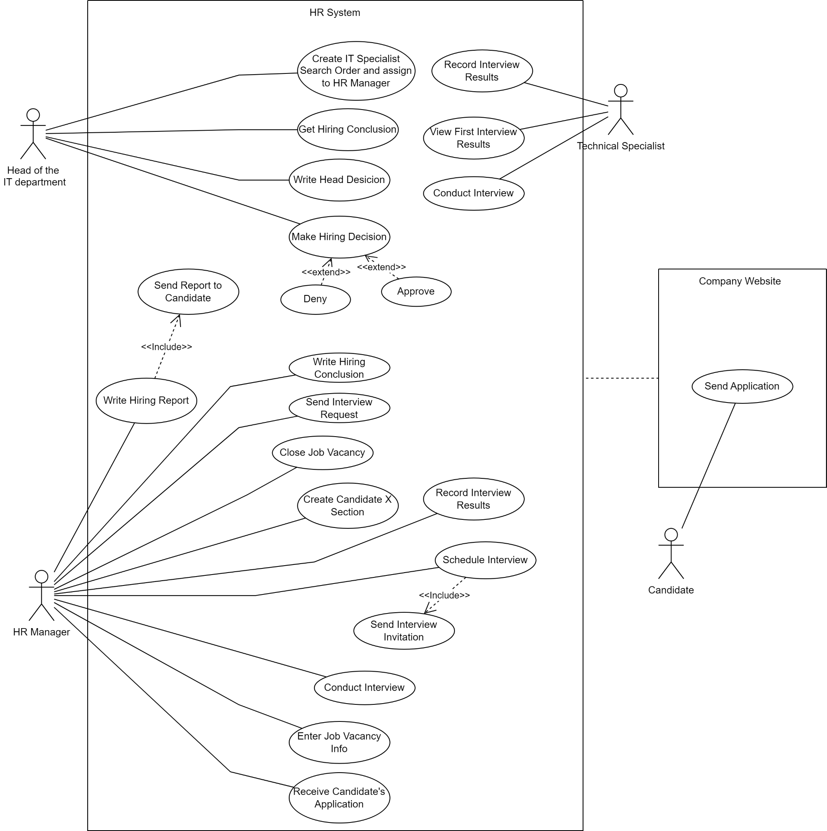

**Опис варіантів використання в табличній формі**

1.

| **Use Cases Description** | |
| --- | --- |
| Name | Create IT Specialist Search Order and assign to HR Manager |
| Goal | To initiate the process of hiring an IT specialist by creating a search order and assigning it to the HR manager. |
| Actors | Head of the IT department |
| Preconditions | The company has an open IT specialist position. The Head of the IT department has access to the HR system. |
| Trigger | The need for a new IT specialist arises in the company. |
| Flow of events | 1. The Head of the IT department logs into the HR system.  2. Сreates a new search order for an IT specialist with specific qualifications.  3. Assigns this order to the HR manager in the system. |
| Post-conditions or Guarantees | A new search order for an IT specialist is created and assigned to the HR manager in the HR system. This initiates the hiring process. |

2.

| **Use Cases Description** | |
| --- | --- |
| Name | Enter Job Vacancy Info |
| Goal | To make the information about the open IT specialist position available to potential candidates. |
| Actors | HR Manager |
| Preconditions | The HR Manager has access to the company website’s admin panel. A new search order for an IT specialist has been created and assigned to the HR manager. |
| Trigger | The HR Manager receives a new search order for an IT specialist. |
| Flow of events | 1. The HR Manager logs into the admin panel of the company website.  2. Navigates to the “Vacancies” section.  3. Enters all relevant information about the open IT specialist position.  4. Saves the changes and publishes the updated “Vacancies” section. |
| Post-conditions or Guarantees | The information about the open IT specialist position is now available on the company website for potential candidates to view and apply. |

3.

| **Use Cases Description** | |
| --- | --- |
| Name | Send Application |
| Goal | To allow the candidate to apply for the open IT specialist position. |
| Actors | Candidate |
| Preconditions | The candidate has found the job vacancy on the company’s IT website and decided to apply. |
| Trigger | The candidate fills out the application form on the company’s IT website. |
| Flow of events | 1. The candidate visits the company’s IT website and navigates to the “Vacancies” section.  2. The candidate finds the open IT specialist position and clicks on “Apply”.  3. The candidate fills out the application form with their personal information, qualifications, and attaches their resume.  4. The candidate submits the application. |
| Post-conditions or Guarantees | The application is received by the HR system and is ready for review by the HR manager. |

4.

| **Use Cases Description** | |
| --- | --- |
| Name | Receive Candidate's Application |
| Goal | To receive and process the application of a potential candidate for the open IT specialist position. |
| Actors | HR Manager |
| Preconditions | The HR Manager has access to the company website’s admin panel. The job vacancy information has been posted on the company website. |
| Trigger | A candidate submits an application for the open IT specialist position through the company website. |
| Flow of events | 1. The HR Manager receives a notification about a new application on the company website.  2. Logs into the admin panel of the company website.  3. Navigates to the section where new applications are stored.  4. Opens and reviews the new application. |
| Post-conditions or Guarantees | The HR Manager has received and reviewed the candidate’s application. The application is ready for further processing. |

5.

| **Use Cases Description** | |
| --- | --- |
| Name | Create Candidate X Section |
| Goal | To create a dedicated section in the HR system for a new candidate, where all information and progress related to this candidate will be stored. |
| Actors | HR Manager |
| Preconditions | The HR Manager has access to the HR system. A new candidate’s application has been received. |
| Trigger | The HR Manager decides to process a new candidate’s application. |
| Flow of events | 1. The HR Manager logs into the HR system.  2. Navigates to the section where candidate information is stored.  3. Creates a new section named “Candidate X”.  4. Enters all relevant information from the candidate’s application into this section. |
| Post-conditions or Guarantees | A new section for “Candidate X” is created in the HR system. All relevant information from the candidate’s application is stored in this section and ready for further processing. |

6.

| **Use Cases Description** | |
| --- | --- |
| Name | Schedule Interview |
| Goal | To schedule an interview with the candidate. |
| Actors | HR Manager |
| Preconditions | The HR Manager has access to the HR system. A new section for the candidate has been created in the HR system. |
| Trigger | The HR Manager decides to schedule an interview with the candidate. |
| Flow of events | 1. The HR Manager logs into the HR system.  2. Navigates to the “Candidate X” section.  3. Selects an option to schedule an interview.  4. Enters the date and time for the interview and saves this information in the system. |
| Post-conditions or Guarantees | An interview with “Candidate X” is scheduled in the HR system. The date and time of the interview are saved and can be viewed in the “Candidate X” section. |

7.

| **Use Cases Description** | |
| --- | --- |
| Name | Send Interview Invitation |
| Goal | To send an invitation to the candidate for the scheduled interview. |
| Actors | HR Manager |
| Preconditions | The HR Manager has access to the HR system. An interview with the candidate has been scheduled. |
| Trigger | The HR Manager decides to send an interview invitation to the candidate. |
| Flow of events | 1. The HR Manager logs into the HR system.  2. Navigates to the “Candidate X” section.  3. Selects an option to send an interview invitation.  4. Enter the date, time, and location of the interview into the invitation.  5. Send the invitation to the candidate’s email address. |
| Post-conditions or Guarantees | An interview invitation has been sent to the candidate. The candidate is informed about the date, time, and location of the interview. |

8.

| **Use Cases Description** | |
| --- | --- |
| Name | Conduct Interview |
| Goal | To conduct an interview with the candidate to assess their qualifications and fit for the open IT specialist position. |
| Actors | HR Manager |
| Preconditions | The HR Manager has scheduled an interview with the candidate. |
| Trigger | The scheduled date and time for the interview arrive. |
| Flow of events | 1. The HR Manager meets with the candidate at the scheduled time.  2. Conducts the interview, asking a series of questions to assess the candidate’s qualifications and fit for the position.  3. Notes down important points and observations during the interview. |
| Post-conditions or Guarantees | The interview has been conducted. The HR Manager has gathered important information about the candidate’s qualifications and fit for the position. |

9.

| **Use Cases Description** | |
| --- | --- |
| Name | Record Interview Results |
| Goal | To document the results of the first interview conducted with the candidate |
| Actors | HR Manager |
| Preconditions | The first interview has been conducted with a candidate |
| Trigger | The HR manager completes an interview with a candidate |
| Flow of events | 1. The HR manager logs into the HR system  2. The HR manager navigates to the relevant section for the candidate  3. The HR manager enters the results of the interview into the system |
| Post-conditions or Guarantees | The results of the interview are recorded in the HR system and can be accessed for future reference |

10.

| **Use Cases Description** | |
| --- | --- |
| Name | Send Interview Request |
| Goal | To request the Technical Specialist for the second interview with the candidate |
| Actors | HR Manager |
| Preconditions | The results of the first interview with HR Manager have been recorded and documented |
| Trigger | The HR manager decides to request the Technical Specialist for the second interview with the candidate |
| Flow of events | 1. The HR manager logs into the HR system  2. The HR manager navigates to the relevant section for the candidate  3. he HR manager creates an interview request and sends it to the Technical Specialist |
| Post-conditions or Guarantees | An interview request is sent to the Technical Specialist |

11.

| **Use Cases Description** | |
| --- | --- |
| Name | View First Interview Results |
| Goal | To review the results of the first interview with the candidate |
| Actors | Technical Specialist |
| Preconditions | The first interview with the candidate has been conducted and the results have been recorded in the HR system |
| Trigger | The HR manager sends a request to the Technical Specialist to schedule a second interview with the candidate |
| Flow of events | 1. The Technical Specialist logs into the HR system  2. The Technical Specialist navigates to the relevant section for the candidate  3. The Technical Specialist reviews the results of the first interview |
| Post-conditions or Guarantees | The Technical Specialist is informed about the results of the first interview and can make an informed decision about scheduling a second interview |

12.

| **Use Cases Description** | |
| --- | --- |
| Name | Conduct Interview |
| Goal | To interview the candidate and assess its qualifications |
| Actors | Technical Specialist |
| Preconditions | The candidate has been invited for an interview |
| Trigger | The candidate is accepted the interview request |
| Flow of events | 1. The Technical Specialist meets with the candidate  2. They conduct the interview, asking various questions to assess the candidate’s qualifications and fit for the role  3. They conclude the interview and thank the candidate for their time |
| Post-conditions or Guarantees | The interview has been conducted and the Technical Specialist has a better understanding of the candidate’s qualifications |

13.

| **Use Cases Description** | |
| --- | --- |
| Name | Record Interview Results |
| Goal | To document the results of the second interview conducted with the candidate |
| Actors | Technical Specialist |
| Preconditions | A second interview has been conducted with a candidate |
| Trigger | The Technical Specialist completes an interview with a candidate |
| Flow of events | 1. The Technical Specialist logs into the HR system  2. The Technical Specialist navigates to the relevant section for the candidate  3. The Technical Specialist enters the results of the second interview into the system |
| Post-conditions or Guarantees | The results of the second interview are recorded in the HR system and can be accessed for future reference |

14.

| **Use Cases Description** | |
| --- | --- |
| Name | Write Hiring Conclusion |
| Goal | To finalize the hiring process by documenting the conclusion of the interviews and the decision made. |
| Actors | HR Manager |
| Preconditions | The interviews with the candidate have been conducted. |
| Trigger | The results of the interviews are documented. |
| Flow of events | 1. The HR manager analyzes the results of the interviews.  2. Documents the report on the candidate for the head of the IT department. |
| Post-conditions or Guarantees | The hiring conclusion is documented in the HR system and ready to be sent to the Head of IT department. |

15.

| **Use Cases Description** | |
| --- | --- |
| Name | Get Hiring Conclusion |
| Goal | To review the hiring conclusion prepared by the HR manager. |
| Actors | Head of the IT department |
| Preconditions | The hiring conclusion has been written by the HR manager. |
| Trigger | The HR manager sends a request to the Head of the department to confirm the Candidate’s acceptance of the job. |
| Flow of events | 1. The head of the department receives the request in the HR system.  2. The head of the department reviews the hiring conclusion in the HR system. |
| Post-conditions or Guarantees | The head of the department is informed about the hiring conclusion and ready to make a hiring decision. |

16.

| **Use Cases Description** | |
| --- | --- |
| Name | Make Hiring Decision |
| Goal | To make the final decision on whether to hire a candidate for the open IT specialist position. |
| Actors | Head of the IT-department |
| Preconditions | The Head of the IT-department has access to the HR system. The hiring process for the IT specialist position has been completed. |
| Trigger | The Head of the IT-department reviews the hiring report and decides to make a final decision. |
| Flow of events | 1. The Head of the IT-department logs into the HR system.  2. Navigates to the “Candidate X” section.  3. Reviews the hiring report, including details about the interviews, evaluations, and recommendations.  4. Makes a final decision on whether to hire the candidate.  5. Documents his decision in the system. |
| Post-conditions or Guarantees | The final decision on whether to hire “Candidate X” is made and documented in the HR system. This decision can be viewed in the “Candidate X” section. |

17.

| **Use Cases Description** | |
| --- | --- |
| Name | Write Head Decision |
| Goal | To document the final decision of the Head of the IT-department regarding the hiring of a candidate. |
| Actors | Head of the IT-department |
| Preconditions | The Head of the IT-department has access to the HR system. The hiring process for the IT specialist position has been completed. |
| Trigger | The Head of the IT-department makes a decision regarding the hiring of a candidate. |
| Flow of events | 1. The Head of the IT-department logs into the HR system.  2. Navigates to the “Candidate X” section.  3. Selects an option to write his decision.  4. Documents his decision, including his reasons and justifications, in the system.  5. Saves his decision in the system. |
| Post-conditions or Guarantees | The final decision of the Head of the IT-department regarding the hiring of “Candidate X” is documented and saved in the HR system. This decision can be viewed in the “Candidate X” section. |

18.

| **Use Cases Description** | |
| --- | --- |
| Name | Deny |
| Goal | To deny the hiring of a candidate for the open IT specialist position. |
| Actors | Head of the IT department |
| Preconditions | The Head of the IT-department has access to the HR system. The hiring process for the IT specialist position has been completed. |
| Trigger | The Head of the IT-department decides to deny the hiring of a candidate. |
| Flow of events | 1. The Head of the IT-department logs into the HR system.  2. Navigates to the “Candidate X” section.  3. Reviews the hiring report and makes a decision.  4. Selects an option to deny the hiring of the candidate.  5. Saves his decision in the system. |
| Post-conditions or Guarantees | The hiring of “Candidate X” has been denied by the Head of the IT-department. This decision is saved in the HR system and can be viewed in the “Candidate X” section. |

19.

| **Use Cases Description** | |
| --- | --- |
| Name | Approve |
| Goal | Head of the IT-department, HR System |
| Actors | Head of the IT-department |
| Preconditions | The Head of the IT-department has access to the HR system. The hiring process for the IT specialist position has been completed. |
| Trigger | The Head of the IT-department decides to approve the hiring of a candidate. |
| Flow of events | 1. The Head of the IT-department logs into the HR system.  2. Navigates to the “Candidate X” section.  3. Reviews the hiring report and makes a decision.  4. Selects an option to approve the hiring of the candidate.  5. Saves his decision in the system. |
| Post-conditions or Guarantees | The hiring of “Candidate X” has been approved by the Head of the IT-department. This decision is saved in the HR system and can be viewed in the “Candidate X” section. |

20.

| **Use Cases Description** | |
| --- | --- |
| Name | Write Hiring Report |
| Goal | To document the outcome of the hiring process in a formal report. |
| Actors | HR Manager |
| Preconditions | The HR Manager has access to the HR system. The hiring process for the IT specialist position has been completed. |
| Trigger | The HR Manager decides to write a report after the hiring process is completed. |
| Flow of events | 1. The HR Manager logs into the HR system.  2. Navigates to the “Candidate X” section.  3. Selects an option to write a report.  4. Documents the outcome of the hiring process, including details about the interviews, evaluations, and final decision, in the report.  5. Saves the report in the system. |
| Post-conditions or Guarantees | A formal hiring report has been written and saved in the HR system. This report provides a comprehensive record of the hiring process and its outcome. |

21.

| **Use Cases Description** | |
| --- | --- |
| Name | Send Report to Candidate |
| Goal | To send a report to the candidate informing them about the outcome of the hiring process. |
| Actors | HR Manager |
| Preconditions | The HR Manager has access to the HR system. The hiring process for the IT specialist position has been completed. |
| Trigger | The HR Manager decides to send a report to the candidate after the hiring process is completed. |
| Flow of events | 1. The HR Manager logs into the HR system.  2. Navigates to the “Candidate X” section.  3. Selects an option to send a report.  4. Enters the outcome of the hiring process into the report.  5. Sends the report to the candidate’s email address. |
| Post-conditions or Guarantees | A report has been sent to the candidate informing them about the outcome of the hiring process. |

22.

| **Use Cases Description** | |
| --- | --- |
| Name | Close Job Vacancy |
| Goal | To close the job vacancy once the hiring process is completed. |
| Actors | HR Manager |
| Preconditions | The HR Manager has access to the HR system. The hiring process for the IT specialist position has been completed. |
| Trigger | The HR Manager decides to close the job vacancy after the hiring process is completed. |
| Flow of events | 1. The HR Manager logs into the HR system.  2. Navigates to the “Vacancies” section.  3. Selects the IT specialist position.  4. Changes the status of the position to “Closed”.  5. Saves the changes in the system. |
| Post-conditions or Guarantees | The job vacancy for the IT specialist position is closed in the HR system, indicating that the position has been filled and no further applications will be accepted. |